UNITED STATES
SECURITIES AND EXCHANGE COMMISSION
Washington, D.C. 20549
FORM 8-K
CURRENT REPORT
Pursuant to Section 13 or 15(d)
of the Securities Exchange Act of 1934
Date of Report (Date of earliest event reported): August 6, 2026

ARDELYX, INC.
(Exact name of registrant as specified in its charter)
Delaware |  |  | 001-36485 |  |  | 26-1303944
(State or other jurisdiction  of incorporation) |  |  | (Commission  File Number) |  |  | (IRS Employer  Identification Number)
400 FIFTH AVE., SUITE 210, WALTHAM, MASSACHUSETTS 02451
(Address of principal executive offices, including Zip Code)
Registrant’s telephone number, including area code: (617) 675-2739
Check the appropriate box below if the Form 8-K filing is intended to simultaneously satisfy the filing obligation of the registrant under any of the following provisions:
☐ |  |  | Written communications pursuant to Rule 425 under the Securities Act (17 CFR 230.425)
☐ |  |  | Soliciting material pursuant to Rule 14a-12 under the Exchange Act (17 CFR 240.14a-12)
☐ |  |  | Pre-commencement communications pursuant to Rule 14d-2(b) under the Exchange Act (17 CFR 240.14d-2(b))
☐ |  |  | Pre-commencement communications pursuant to Rule 13e-4(c) under the Exchange Act (17 CFR 240.13e-4(c))
Securities registered pursuant to Section 12(b) of the Act:
Title of each class |  |  |  |  |  | Trading Symbol(s) |  |  |  |  |  | Name of each exchange on which registered
Common Stock, par value $0.0001 per share |  |  |  |  |  | ARDX |  |  |  |  |  | The Nasdaq Global Market
Indicate by check mark whether the registrant is an emerging growth company as defined in Rule 405 of the Securities Act of 1933 (§230.405 of this chapter) or Rule 12b-2 of the Securities Exchange Act of 1934 (§240.12b-2 of this chapter).
Emerging growth company ☐
If an emerging growth company, indicate by check mark if the registrant has elected not to use the extended transition period for complying with any new or revised financial accounting standards provided pursuant to Section 13(a) of the Exchange Act. o

Item 2.02 Results of Operations and Financial Condition.
On August 6, 2026, Ardelyx, Inc. (the “Company”) announced its financial results for the quarter ended June 30, 2026. The full text of the press release issued in connection with the announcement is furnished as Exhibit 99.1 to this Current Report on Form 8-K.
The information furnished under this Item 2.02, including Exhibit 99.1 hereto, shall not be considered “filed” under the Securities Exchange Act of 1934, as amended (the “Exchange Act”), nor shall it be incorporated by reference into any future filing under the Securities Act of 1933, as amended (the “Securities Act”), or under the Exchange Act, unless the Company expressly sets forth in such future filing that such information is to be considered “filed” or incorporated by reference therein.

Item 7.01 Regulation FD Disclosure.

On August 6, 2026, the Company will host a conference call to discuss its financial results for the quarter ended June 30, 2026. A copy of the earnings presentation that will be used during this conference call is furnished as Exhibit 99.2 to this Current Report on Form 8-K and is incorporated herein by reference.
The information furnished under this Item 7.01, including Exhibit 99.2 hereto, shall not be considered “filed” under the Exchange Act nor shall it be incorporated by reference into any future filing under the Securities Act, or under the Exchange Act, unless the Company expressly sets forth in such future filing that such information is to be considered “filed” or incorporated by reference therein.

Item 9.01 Financial Statements and Exhibits.
(d) Exhibits.
Exhibit No. |  |  |  |  |  | Description
99.1 |  |  |  |  |  | Press Release of Ardelyx, Inc.
99.2 |  |  |  |  |  | Earnings Presentation of Ardelyx, Inc.
104 |  |  |  |  |  | Cover Page Interactive Data File (embedded within the Inline XBRL document).

SIGNATURE
Pursuant to the requirements of the Securities Exchange Act of 1934, as amended, the registrant has duly caused this report to be signed on its behalf by the undersigned hereunto duly authorized.
Date: August 6, 2026 |  |  | ARDELYX, INC.
 |  |  | By: |  |  | /s/ Susan Hohenleitner
 |  |  |  |  |  | Susan Hohenleitner
 |  |  |  |  |  | Chief Financial Officer



Exhibit 99.1
Ardelyx Reports Second Quarter 2026 Financial Results and Provides Business Update
Q2 2026 total product revenue of $118.1 million, reflecting 31% growth year-over-year
IBSRELA Q2 2026 revenue growth of 33% year-over-year to $86.2 million
XPHOZAH Q2 2026 revenue growth of 27% year-over-year to $31.9 million
Strong financial position with $281.8 million in cash, cash equivalents and investments as of June 30, 2026
Revising FY 2026 and long-term guidance
Conference call scheduled for 4:30 PM Eastern Time
WALTHAM, Mass., August 6, 2026 – Ardelyx Inc. (Nasdaq: ARDX), (“Ardelyx” or the “Company”) a commercial-stage biopharmaceutical company focused on the development and commercialization of innovative medicines that meet significant unmet medical needs, today reported financial results for the second quarter ended June 30, 2026, and provided a business update.

“In the second quarter of 2026, we delivered combined revenue of $118 million, up 31% year over year, the largest quarterly revenue in our Company’s history,” said Mike Raab, President and Chief Executive Officer of Ardelyx. “XPHOZAH had an excellent quarter, reinforcing the strength of our commercial foundation. The demand for IBSRELA was strong despite revenues below our expectations resulting from significantly increased utilization management processes from payors that we are actively addressing. The underlying fundamentals of our business remain robust and considering the recent market dynamics, we are updating our full year and future growth outlook. We are generating significant revenue, and we are moving towards profitability in 2027. We are a high-growth company with the demonstrated ability to effectively manage through external challenges, and I have full confidence in our team’s ability to execute. Our commitment to patients and to creating long-term shareholder value remains steadfast.”

Product Revenue
Revenue for IBSRELA® (tenapanor) during the second quarter of 2026 was $86.2 million, reflecting year-over-year growth of 33%. The growth was driven by increases in refills and total prescriptions, reaching the highest demand quarter to date.

Revenue for XPHOZAH® (tenapanor) during the second quarter of 2026 was $31.9 million, reflecting year-over-year growth of 27%. The growth was driven by a strong increase in total writers, new and refill prescriptions, and total prescriptions.

Updated Financial Guidance and Outlook
•Full-year 2026 revenue guidance for IBSRELA revised to be between $350 and $370 million.
•Full-year 2026 revenue guidance for XPHOZAH reiterated to be between $110 and $120 million.
•OPEX guidance revised to be below $500 million.
•IBSRELA long-term guidance of achieving $1B in revenue remains, and the Company is evaluating the evolving market dynamics and their impact on the timing of this achievement.
•XPHOZAH long-term guidance is being pulled as the Company assesses evolving market dynamics and growth rates, which have the potential to reshape the long-term market opportunity.

Advancing a Pipeline of Important Medicines
•IBSRELA is being evaluated for the treatment of chronic idiopathic constipation (CIC) in adults in a Phase 3 clinical trial, ACCEL. The Company is on track to complete enrollment by the end of 2026 and to announce top-line data in the second half of 2027.
•IBSRELA is also being evaluated in multiple pediatric clinical trials which could potentially provide six months of additional patent life for tenapanor.
•RDX10531, the Company’s next-generation NHE3 inhibitor is currently being tested in IND-enabling studies. If successful, RDX10531 has potential for broad applications across multiple therapeutic areas.

Corporate Developments
•On June 29, 2026, the Company drew $50 million from its existing financing arrangement with SLR Investment Corp. for general corporate purposes and to enhance flexibility to support its ongoing strategic initiatives in line with its capital allocation strategy.
•On June 26, 2026, the U.S. Court of Appeals for the D.C. Circuit affirmed the district court’s dismissal of our lawsuit against CMS related to CMS reimbursement classification of XPHOZAH and we will not pursue further litigation on this matter.

Second Quarter 2026 Financial Results
•Cash Position: As of June 30, 2026, the Company had total cash, cash equivalents and short-term investments of $281.8 million, compared to total cash, cash equivalents and short-term investments of $264.7 million as of December 31, 2025.
•Revenues: Total product revenue for the quarter ended June 30, 2026 was $118.1 million, compared to $90.1 million for the quarter ended June 30, 2025, reflecting 31% growth, driven by increased demand.
•R&D Expenses: Research and development expenses were $26.1 million for the quarter ended June 30, 2026, compared to $15.7 million for the quarter ended June 30, 2025. The increase was primarily related to investments in the ACCEL Phase 3 trial for CIC.
•SG&A Expenses: Selling, general and administrative expenses were $101.4 million for the quarter ended June 30, 2026, compared to $84.0 million for the quarter ended June 30, 2025. The increase was related to deliberate investments to address the access barriers and drive future adoption of IBSRELA.
•Net Loss: Net loss for the quarter ended June 30, 2026 was $16.7 million, or $(0.07) per share, compared to net loss of $19.1 million, or $(0.08) per share, for the quarter ended June 30, 2025. The net loss for the second quarter of 2026 included share-based compensation expense of $15.3 million.

Conference Call Details
The company will host a conference call today, August 6, 2026, at 4:30 PM ET to discuss today’s announcement. To participate in the conference call, please dial (877) 346-6112 (domestic) or +1 (848) 280-6350 (international) and ask to be joined into the Ardelyx call. A webcast of the call can also be accessed by visiting the Investor page of the company’s website, https://ardelyx.com/, and will be available on the website following the call.
IMPORTANT SAFETY INFORMATION (IBSRELA)
WARNING: RISK OF SERIOUS DEHYDRATION IN PEDIATRIC PATIENTS
IBSRELA is contraindicated in patients less than 6 years of age; in nonclinical studies in young juvenile rats administration of tenapanor caused deaths presumed to be due to dehydration. Avoid use of IBSRELA in patients 6 years to less than 12 years of age. The safety and effectiveness of IBSRELA have not been established in patients less than 18 years of age.
CONTRAINDICATIONS
•IBSRELA is contraindicated in patients less than 6 years of age due to the risk of serious dehydration.
•IBSRELA is contraindicated in patients with known or suspected mechanical gastrointestinal obstruction.
WARNINGS AND PRECAUTIONS
Risk of Serious Dehydration in Pediatric Patients
•IBSRELA is contraindicated in patients below 6 years of age. The safety and effectiveness of IBSRELA in patients less than 18 years of age have not been established. In young juvenile rats (less than 1 week old; approximate human age equivalent of less than 2 years of age), decreased body weight and deaths occurred, presumed to be due to dehydration, following oral administration of tenapanor. There are no data available in older juvenile rats (human age equivalent 2 years to less than 12 years).
•Avoid the use of IBSRELA in patients 6 years to less than 12 years of age. Although there are no data in older juvenile rats, given the deaths in younger rats and the lack of clinical safety and efficacy data in pediatric patients, avoid the use of IBSRELA in patients 6 years to less than 12 years of age.
Diarrhea
Diarrhea was the most common adverse reaction in two randomized, double-blind, placebo-controlled trials of IBS-C. Severe diarrhea was reported in 2.5% of IBSRELA-treated patients. If severe diarrhea occurs, suspend dosing and rehydrate patient.

MOST COMMON ADVERSE REACTIONS
The most common adverse reactions in IBSRELA-treated patients (incidence ≥2% and greater than placebo) were: diarrhea (16% vs 4% placebo), abdominal distension (3% vs <1%), flatulence (3% vs 1%) and dizziness (2% vs <1%).
INDICATION
IBSRELA (tenapanor) is indicated for the treatment of Irritable Bowel Syndrome with Constipation (IBS-C) in adults.
Please see full Prescribing Information, including Boxed Warning, for additional risk information.
IMPORTANT SAFETY INFORMATION (XPHOZAH)
CONTRAINDICATIONS
XPHOZAH is contraindicated in:
•Pediatric patients under 6 years of age
•Patients with known or suspected mechanical gastrointestinal obstruction
WARNINGS AND PRECAUTIONS
Diarrhea
Patients may experience severe diarrhea. Treatment with XPHOZAH should be discontinued in patients who develop severe diarrhea.
MOST COMMON ADVERSE REACTIONS
Diarrhea, which occurred in 43-53% of patients, was the only adverse reaction reported in at least 5% of XPHOZAH-treated patients with CKD on dialysis across trials. The majority of diarrhea events in the XPHOZAH-treated patients were reported to be mild-to-moderate in severity and resolved over time, or with dose reduction. Diarrhea was typically reported soon after initiation but could occur at any time during treatment with XPHOZAH. Severe diarrhea was reported in 5% of XPHOZAH-treated patients in these trials.
INDICATION
XPHOZAH (tenapanor), 30 mg BID, is indicated to reduce serum phosphorus in adults with chronic kidney disease (CKD) on dialysis as add-on therapy in patients who have an inadequate response to phosphate binders or who are intolerant of any dose of phosphate binder therapy.
For additional safety information, please see full Prescribing Information.
About Ardelyx
Ardelyx is a commercial-stage biopharmaceutical company focused on the development and commercialization of innovative medicines that meet significant unmet medical needs. Ardelyx has two commercial products approved in the United States, IBSRELA® (tenapanor) and XPHOZAH® (tenapanor). The company’s pipeline includes the Phase 3 development of IBSRELA for chronic idiopathic constipation (CIC) and RDX10531, a next-generation NHE3 inhibitor with potential application across multiple therapeutic areas. Ardelyx works with partners to develop and commercialize our products outside of the United States. For more information, please visit https://ardelyx.com/ and connect with us on X (formerly known as Twitter), LinkedIn and Facebook.

Forward Looking Statements
To the extent that statements contained in this press release are not descriptions of historical facts regarding Ardelyx, they are forward-looking statements reflecting the current beliefs and expectations of management made pursuant to the safe harbor of the Private Securities Reform Act of 1995, including Ardelyx’s current expectations regarding: the long term potential for Ardelyx’s existing commercial products; our anticipated move towards profitability in 2027; opportunities for continued IBSRELA growth, including our expectation for achieving one billion in revenue; our U.S. net product sales revenue and OPEX guidance for full year 2026; and our expectations and timing regarding pipeline development activities, including enrollment in and expected topline readout of the Phase 3 ACCEL trial, the potential for additional patent life for IBSRELA as a result of ongoing pediatric clinical trials and RDX10531’s potential for broad applications across multiple therapeutic areas. Such forward-looking statements involve known and unknown risks, uncertainties and other factors that are in some cases beyond our control, that could cause actual outcomes or results to differ materially from those expressed or implied by the forward-looking statements. Such risks and uncertainties include, among others, uncertainties associated with the development of, regulatory process for, and commercialization of drugs in the U.S. and internationally. Ardelyx undertakes no obligation to

update or revise any forward-looking statements. For a further description of the risks and uncertainties that could cause actual results to differ from those expressed in these forward-looking statements, as well as risks relating to Ardelyx’s business in general, please refer to Ardelyx’s Quarterly Report on Form 10-Q filed with the Securities and Exchange Commission on August 6, 2026, and its future current and periodic reports to be filed with the Securities and Exchange Commission.

Investor Contact:
Lisa Caperelli
lcaperelli@ardelyx.com

Ardelyx, Inc.
Condensed Balance Sheets
(Unaudited)
(in thousands)
 |  |  | June 30, 2026 |  |  |  |  |  | December 31, 2025
Assets
Cash and cash equivalents |  |  | $ | 97,191 |  |  |  |  | $ | 67,999
Short-term investments |  |  | 184,639 |  |  |  |  |  | 196,690
Accounts receivable |  |  | 100,352 |  |  |  |  |  | 71,848
Prepaid commercial manufacturing |  |  | 23,191 |  |  |  |  |  | 14,479
Inventory |  |  | 138,985 |  |  |  |  |  | 123,107
Property and equipment, net |  |  | 1,781 |  |  |  |  |  | 2,184
Right-of-use assets |  |  | 4,065 |  |  |  |  |  | 4,795
Prepaid and other assets |  |  | 25,690 |  |  |  |  |  | 20,502
Total assets |  |  | $ | 575,894 |  |  |  |  | $ | 501,604
Liabilities and stockholders’ equity
Accounts payable |  |  | $ | 38,410 |  |  |  |  | $ | 19,235
Accrued compensation and benefits |  |  | 14,564 |  |  |  |  |  | 19,108
Current portion of operating lease liability |  |  | 1,545 |  |  |  |  |  | 1,479
Deferred revenue |  |  | 20,437 |  |  |  |  |  | 14,905
Accrued expenses and other liabilities |  |  | 73,785 |  |  |  |  |  | 51,218
Long-term debt |  |  | 251,823 |  |  |  |  |  | 202,834
Deferred royalty obligation related to the sale of future royalties |  |  | 26,317 |  |  |  |  |  | 25,876
Total stockholders’ equity |  |  | 149,013 |  |  |  |  |  | 166,949
Total liabilities and stockholders’ equity |  |  | $ | 575,894 |  |  |  |  | $ | 501,604

Ardelyx, Inc.
Condensed Statements of Operations
(Unaudited)
(in thousands, except share and per share amounts)
 |  |  | Three Months Ended June 30, |  |  |  |  |  |  |  |  |  |  |  | Six Months Ended June 30,
 |  |  | 2026 |  |  |  |  |  | 2025 |  |  |  |  |  | 2026 |  |  |  |  |  | 2025
Revenues
Product sales, net
IBSRELA |  |  | $ | 86,243 |  |  |  |  | $ | 65,045 |  |  |  |  | $ | 156,317 |  |  |  |  | $ | 109,448
XPHOZAH |  |  | 31,886 |  |  |  |  |  | 25,032 |  |  |  |  |  | 55,185 |  |  |  |  |  | 48,443
Total product sales, net |  |  | 118,129 |  |  |  |  |  | 90,077 |  |  |  |  |  | 211,502 |  |  |  |  |  | 157,891
Product supply revenue |  |  | 1,976 |  |  |  |  |  | 6,185 |  |  |  |  |  | 2,330 |  |  |  |  |  | 6,439
Licensing revenue |  |  | 96 |  |  |  |  |  | 20 |  |  |  |  |  | 147 |  |  |  |  |  | 5,040
Non-cash royalty revenue related to the sale of future royalties |  |  | 676 |  |  |  |  |  | 1,380 |  |  |  |  |  | 1,371 |  |  |  |  |  | 2,406
Total revenues |  |  | 120,877 |  |  |  |  |  | 97,662 |  |  |  |  |  | 215,350 |  |  |  |  |  | 171,776
Costs and operating expenses
Cost of sales(1) |  |  | 5,759 |  |  |  |  |  | 12,403 |  |  |  |  |  | 10,570 |  |  |  |  |  | 24,706
Research and development |  |  | 26,103 |  |  |  |  |  | 15,666 |  |  |  |  |  | 46,291 |  |  |  |  |  | 30,604
Selling, general and administrative |  |  | 101,440 |  |  |  |  |  | 83,988 |  |  |  |  |  | 203,707 |  |  |  |  |  | 167,210
Total costs and operating expenses |  |  | 133,302 |  |  |  |  |  | 112,057 |  |  |  |  |  | 260,568 |  |  |  |  |  | 222,520
Loss from operations |  |  | (12,425) |  |  |  |  |  | (14,395) |  |  |  |  |  | (45,218) |  |  |  |  |  | (50,744)
Interest expense |  |  | (4,957) |  |  |  |  |  | (4,356) |  |  |  |  |  | (10,556) |  |  |  |  |  | (8,547)
Non-cash interest expense related to the sale of future royalties |  |  | (1,267) |  |  |  |  |  | (2,219) |  |  |  |  |  | (2,584) |  |  |  |  |  | (4,290)
Other income, net |  |  | 2,038 |  |  |  |  |  | 1,892 |  |  |  |  |  | 4,150 |  |  |  |  |  | 4,218
Loss before provision for income taxes |  |  | (16,611) |  |  |  |  |  | (19,078) |  |  |  |  |  | (54,208) |  |  |  |  |  | (59,363)
Provision for income taxes |  |  | 110 |  |  |  |  |  | 1 |  |  |  |  |  | 118 |  |  |  |  |  | 860
Net loss |  |  | $ | (16,721) |  |  |  |  | $ | (19,079) |  |  |  |  | $ | (54,326) |  |  |  |  | $ | (60,223)
Net loss per share of common stock - basic and diluted |  |  | $ | (0.07) |  |  |  |  | $ | (0.08) |  |  |  |  | $ | (0.22) |  |  |  |  | $ | (0.25)
Shares used in computing net loss per share - basic and diluted |  |  | 248,067,253 |  |  |  |  |  | 239,928,570 |  |  |  |  |  | 246,967,275 |  |  |  |  |  | 239,279,962
(1) Prior year amounts have been reclassified to conform to the current year presentation.


This presentation is intended for investor purposes only and is not intended for promotional purposes. 1Q2 2026 Earnings Q2 2026 Earnings Call August 6, 2026


2Q2 2026 EarningsThis presentation is intended for investor purposes only and is not intended for promotional purposes. Introduction Lisa Caperelli Senior Vice President, Investor Relations & Corporate Communications


Participants Mike Raab President & Chief Executive Officer Eric Foster Chief Commercial Officer Sue Hohenleitner, CPA, CMA Chief Financial Officer 3This presentation is intended for investor purposes only and is not intended for promotional purposes. Q2 2026 Earnings

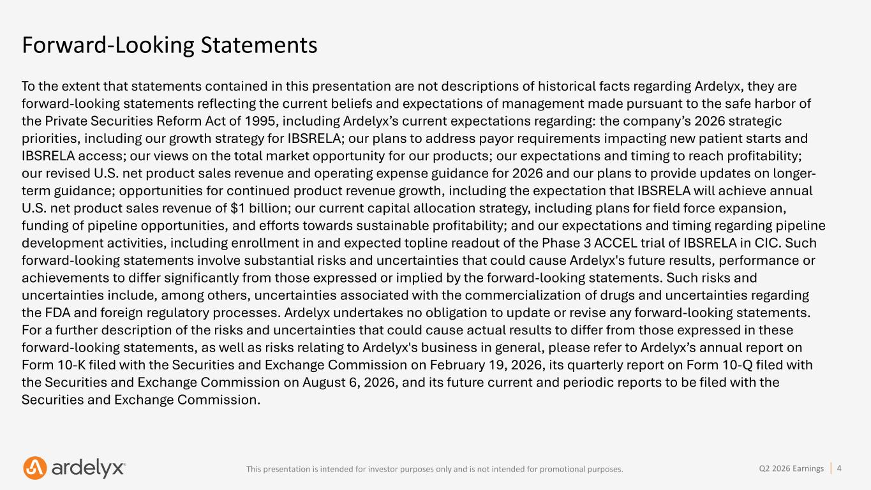
This presentation is intended for investor purposes only and is not intended for promotional purposes. 4Q2 2026 Earnings Forward-Looking Statements To the extent that statements contained in this presentation are not descriptions of historical facts regarding Ardelyx, they are forward-looking statements reflecting the current beliefs and expectations of management made pursuant to the safe harbor of the Private Securities Reform Act of 1995, including Ardelyx’s current expectations regarding: the company’s 2026 strategic priorities, including our growth strategy for IBSRELA; our plans to address payor requirements impacting new patient starts and IBSRELA access; our views on the total market opportunity for our products; our expectations and timing to reach profitability; our revised U.S. net product sales revenue and operating expense guidance for 2026 and our plans to provide updates on longer- term guidance; opportunities for continued product revenue growth, including the expectation that IBSRELA will achieve annual U.S. net product sales revenue of $1 billion; our current capital allocation strategy, including plans for field force expansion, funding of pipeline opportunities, and efforts towards sustainable profitability; and our expectations and timing regarding pipeline development activities, including enrollment in and expected topline readout of the Phase 3 ACCEL trial of IBSRELA in CIC. Such forward-looking statements involve substantial risks and uncertainties that could cause Ardelyx's future results, performance or achievements to differ significantly from those expressed or implied by the forward-looking statements. Such risks and uncertainties include, among others, uncertainties associated with the commercialization of drugs and uncertainties regarding the FDA and foreign regulatory processes. Ardelyx undertakes no obligation to update or revise any forward-looking statements. For a further description of the risks and uncertainties that could cause actual results to differ from those expressed in these forward-looking statements, as well as risks relating to Ardelyx's business in general, please refer to Ardelyx’s annual report on Form 10-K filed with the Securities and Exchange Commission on February 19, 2026, its quarterly report on Form 10-Q filed with the Securities and Exchange Commission on August 6, 2026, and its future current and periodic reports to be filed with the Securities and Exchange Commission.

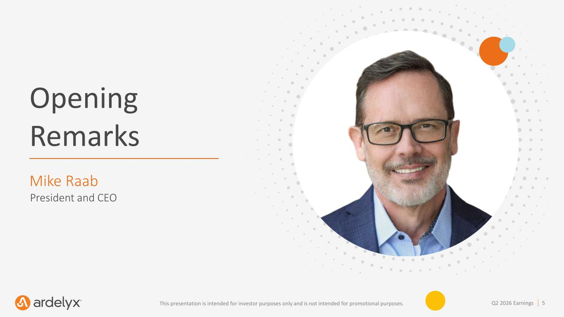
5Q2 2026 EarningsThis presentation is intended for investor purposes only and is not intended for promotional purposes. Opening Remarks Mike Raab President and CEO

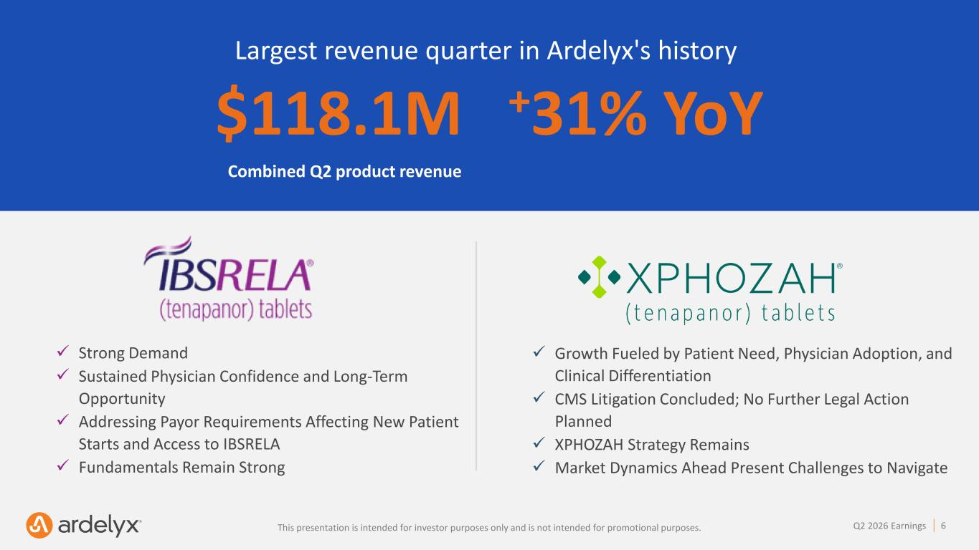
This presentation is intended for investor purposes only and is not intended for promotional purposes. 6Q2 2026 Earnings $118.1M +31% YoY ✓ Strong Demand ✓ Sustained Physician Confidence and Long-Term Opportunity ✓ Addressing Payor Requirements Affecting New Patient Starts and Access to IBSRELA ✓ Fundamentals Remain Strong Largest revenue quarter in Ardelyx's history Combined Q2 product revenue ✓ Growth Fueled by Patient Need, Physician Adoption, and Clinical Differentiation ✓ CMS Litigation Concluded; No Further Legal Action Planned ✓ XPHOZAH Strategy Remains ✓ Market Dynamics Ahead Present Challenges to Navigate i i i i f i l i i f i l .

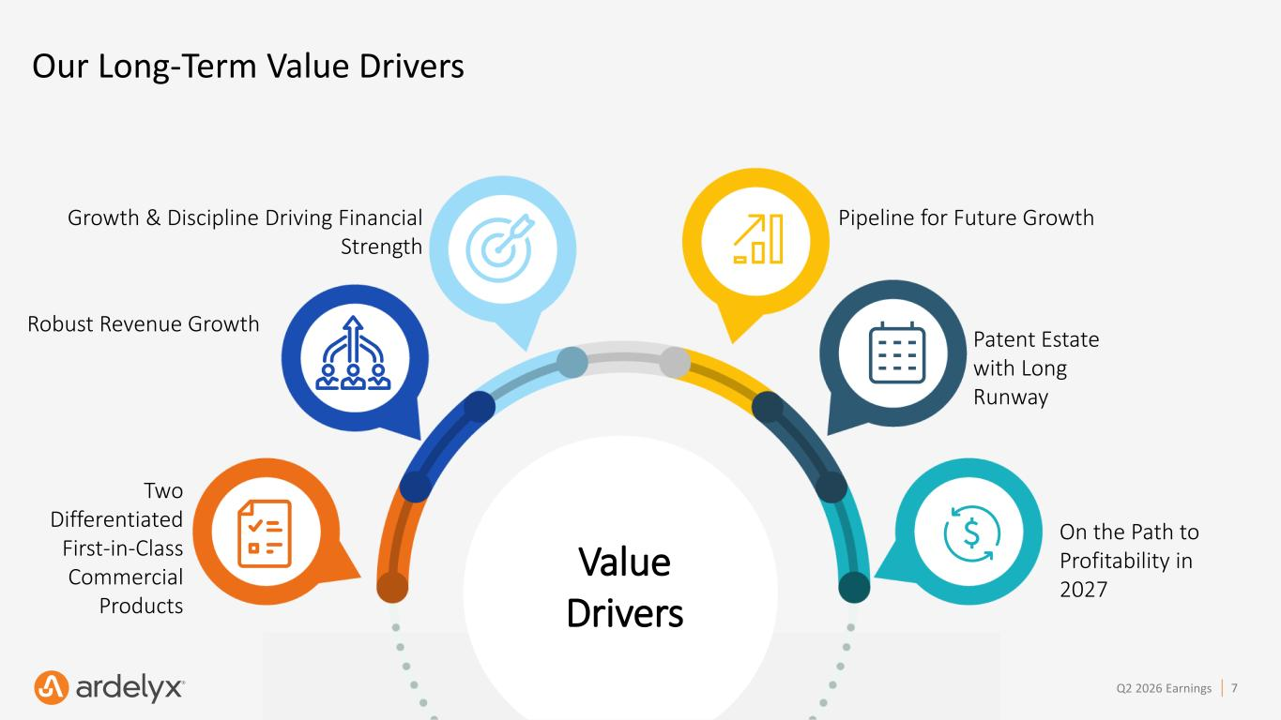
This presentation is intended for investor purposes only and is not intended for promotional purposes. 7Q2 2026 Earnings Our Long-Term Value Drivers Value Drivers On the Path to Profitability in 2027 Patent Estate with Long Runway Pipeline for Future Growth Two Differentiated First-in-Class Commercial Products Robust Revenue Growth Growth & Discipline Driving Financial Strength

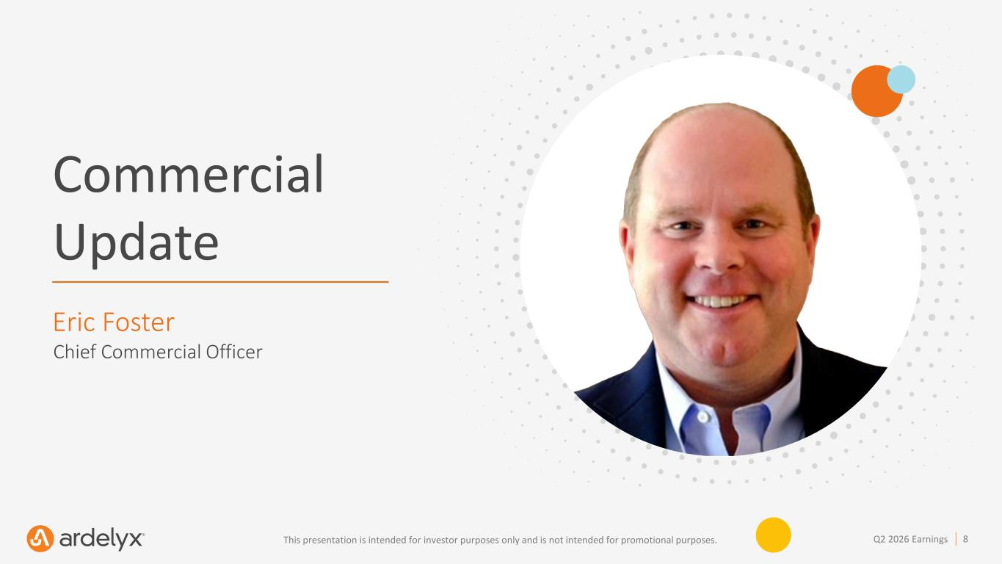
8Q2 2026 EarningsThis presentation is intended for investor purposes only and is not intended for promotional purposes. Commercial Update Eric Foster Chief Commercial Officer

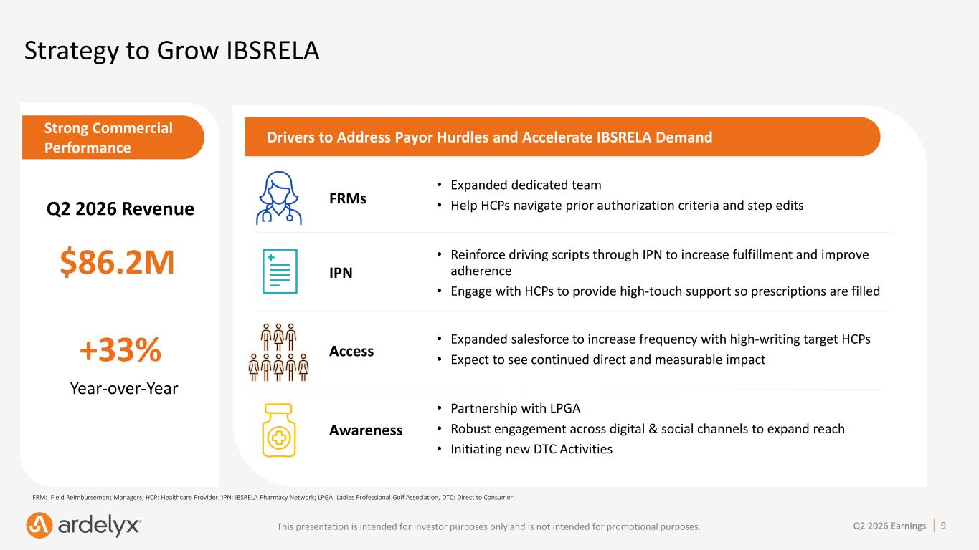
This presentation is intended for investor purposes only and is not intended for promotional purposes. 9Q2 2026 Earnings Access Strong Commercial Performance Strategy to Grow IBSRELA Q2 2026 Revenue $86.2M +33% Drivers to Address Payor Hurdles and Accelerate IBSRELA Demand FRMs • Expanded dedicated team • Help HCPs navigate prior authorization criteria and step edits IPN • Reinforce driving scripts through IPN to increase fulfillment and improve adherence • Engage with HCPs to provide high-touch support so prescriptions are filled • Expanded salesforce to increase frequency with high-writing target HCPs • Expect to see continued direct and measurable impact Awareness • Partnership with LPGA • Robust engagement across digital & social channels to expand reach • Initiating new DTC Activities Year-over-Year FRM: Field Reimbursement Managers; HCP: Healthcare Provider; IPN: IBSRELA Pharmacy Network; LPGA: Ladies Professional Golf Association, DTC: Direct to Consumer

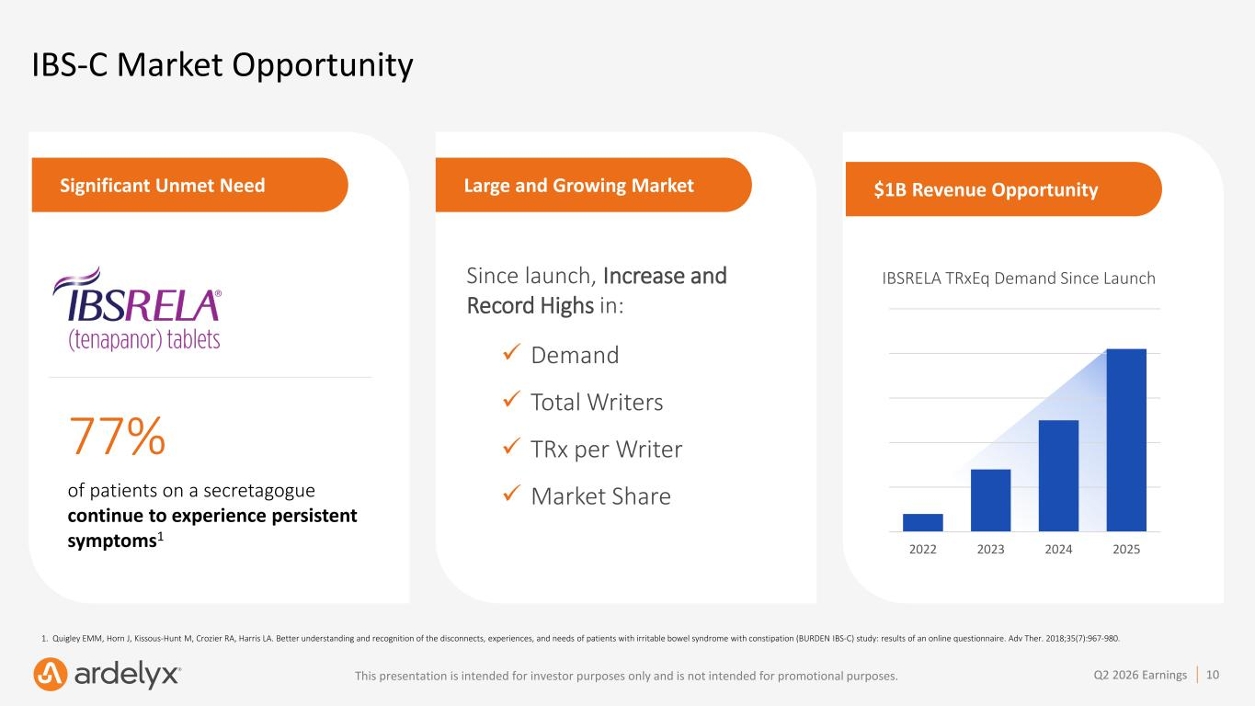
This presentation is intended for investor purposes only and is not intended for promotional purposes. 10Q2 2026 Earnings Large and Growing MarketSignificant Unmet Need IBS-C Market Opportunity 1. Quigley EMM, Horn J, Kissous-Hunt M, Crozier RA, Harris LA. Better understanding and recognition of the disconnects, experiences, and needs of patients with irritable bowel syndrome with constipation (BURDEN IBS-C) study: results of an online questionnaire. Adv Ther. 2018;35(7):967-980. 77% of patients on a secretagogue continue to experience persistent symptoms1 6.9 IBSRELA TRxEq Demand Since Launch 2022 2023 2024 2025 Since launch, Increase and Record Highs in: ✓ Demand ✓ Total Writers ✓ TRx per Writer ✓ Market Share $1B Revenue Opportunity

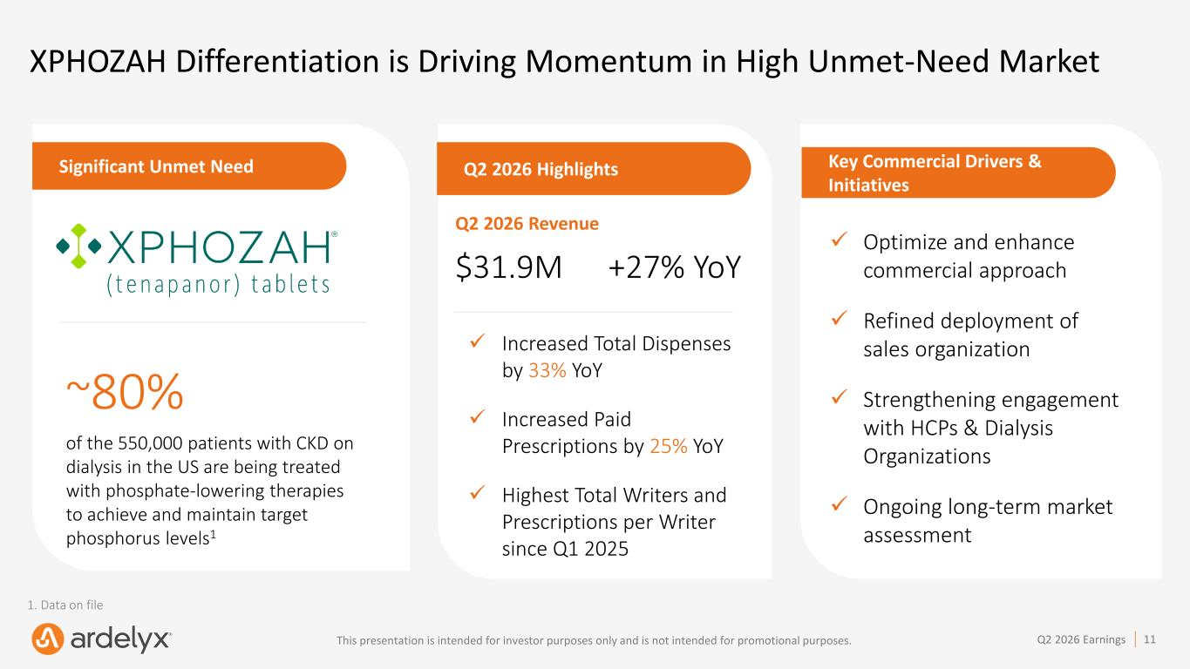
This presentation is intended for investor purposes only and is not intended for promotional purposes. 11Q2 2026 Earnings XPHOZAH Differentiation is Driving Momentum in High Unmet-Need Market Key Commercial Drivers & Initiatives ✓ Optimize and enhance commercial approach ✓ Refined deployment of sales organization ✓ Strengthening engagement with HCPs & Dialysis Organizations ✓ Ongoing long-term market assessment Significant Unmet Need ~80% of the 550,000 patients with CKD on dialysis in the US are being treated with phosphate-lowering therapies to achieve and maintain target phosphorus levels1 1. Data on file Q2 2026 Highlights Q2 2026 Revenue $31.9M +27% YoY ✓ Increased Total Dispenses by 33% YoY ✓ Increased Paid Prescriptions by 25% YoY ✓ Highest Total Writers and Prescriptions per Writer since Q1 2025


12Q2 2026 EarningsThis presentation is intended for investor purposes only and is not intended for promotional purposes. Financial Performance Sue Hohenleitner, CPA, CMA Chief Financial Officer

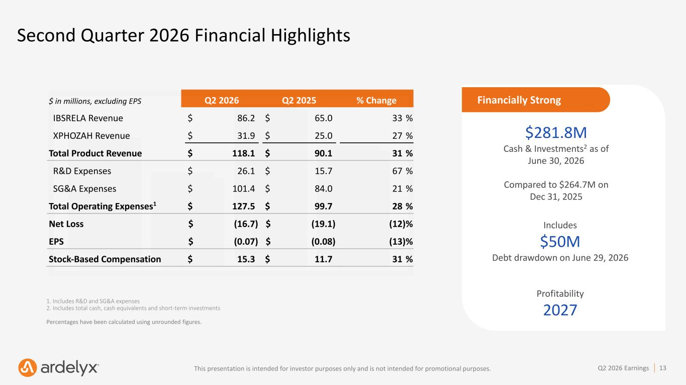
This presentation is intended for investor purposes only and is not intended for promotional purposes. 13Q2 2026 Earnings Second Quarter 2026 Financial Highlights 1. Includes R&D and SG&A expenses 2. Includes total cash, cash equivalents and short-term investments Percentages have been calculated using unrounded figures. $281.8M Cash & Investments2 as of June 30, 2026 Compared to $264.7M on Dec 31, 2025 Includes $50M Debt drawdown on June 29, 2026 Profitability 2027 Financially Strong$ in millions, excluding EPS Q2 2026 Q2 2025 % Change IBSRELA Revenue $ 86.2 $ 65.0 33 % XPHOZAH Revenue $ 31.9 $ 25.0 27 % Total Product Revenue $ 118.1 $ 90.1 31 % R&D Expenses $ 26.1 $ 15.7 67 % SG&A Expenses $ 101.4 $ 84.0 21 % Total Operating Expenses1 $ 127.5 $ 99.7 28 % Net Loss $ (16.7) $ (19.1) (12) % EPS $ (0.07) $ (0.08) (13) % Stock-Based Compensation $ 15.3 $ 11.7 31 %

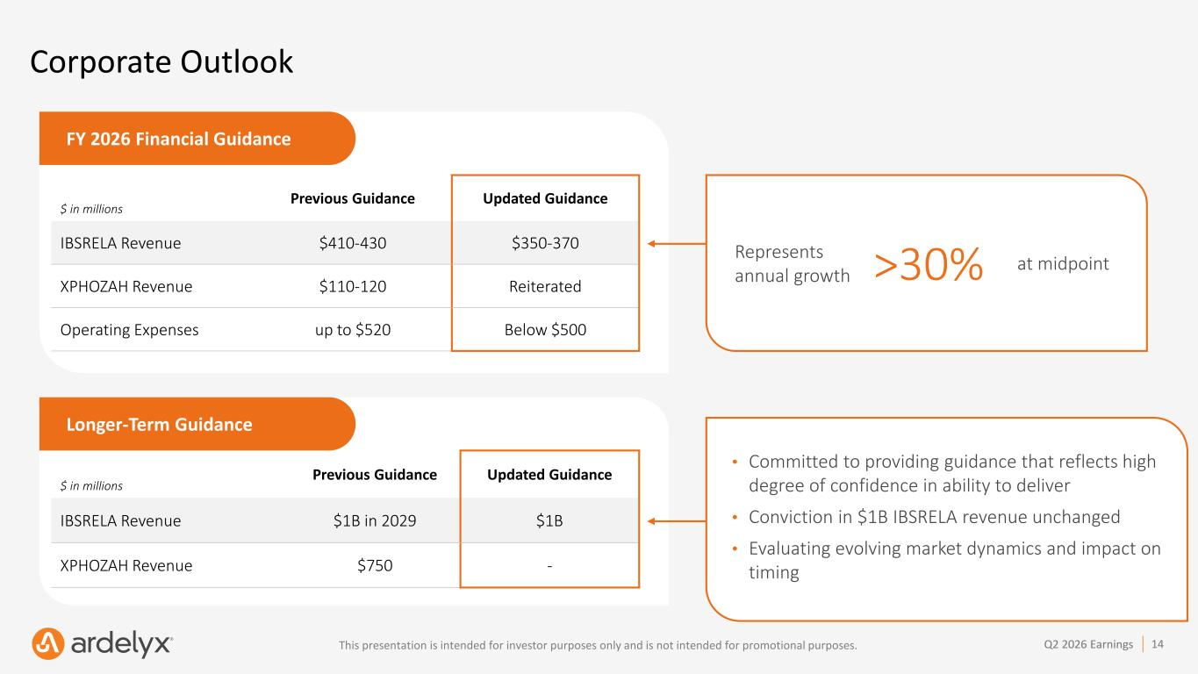
This presentation is intended for investor purposes only and is not intended for promotional purposes. 14Q2 2026 Earnings Corporate Outlook FY 2026 Financial Guidance $ in millions Previous Guidance Updated Guidance IBSRELA Revenue $410-430 $350-370 XPHOZAH Revenue $110-120 Reiterated Operating Expenses up to $520 Below $500 Longer-Term Guidance $ in millions Previous Guidance Updated Guidance IBSRELA Revenue $1B in 2029 $1B XPHOZAH Revenue $750 - • Committed to providing guidance that reflects high degree of confidence in ability to deliver • Conviction in $1B IBSRELA revenue unchanged • Evaluating evolving market dynamics and impact on timing Represents annual growth >30% at midpoint

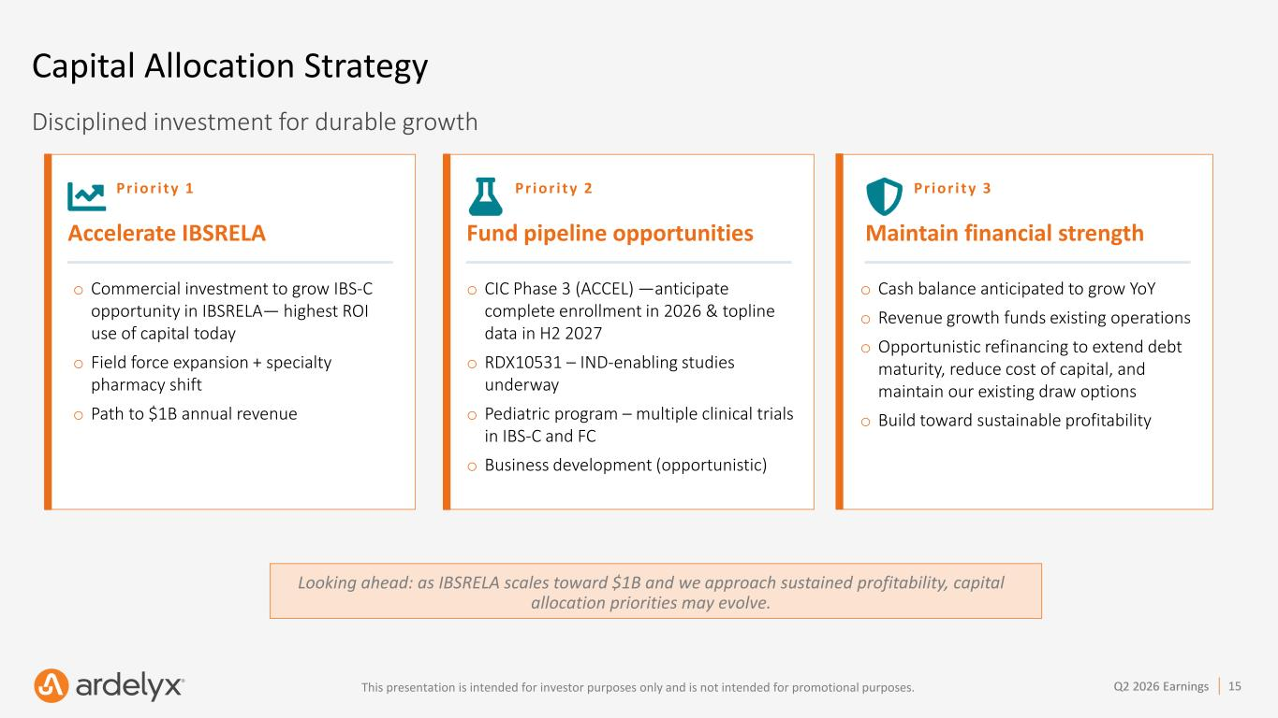
This presentation is intended for investor purposes only and is not intended for promotional purposes. 15Q2 2026 Earnings Capital Allocation Strategy Looking ahead: as IBSRELA scales toward $1B and we approach sustained profitability, capital allocation priorities may evolve. Disciplined investment for durable growth Pr i or i ty 1 Accelerate IBSRELA o Commercial investment to grow IBS-C opportunity in IBSRELA— highest ROI use of capital today o Field force expansion + specialty pharmacy shift o Path to $1B annual revenue Pr i or i t y 2 Fund pipeline opportunities o CIC Phase 3 (ACCEL) —anticipate complete enrollment in 2026 & topline data in H2 2027 o RDX10531 – IND-enabling studies underway o Pediatric program – multiple clinical trials in IBS-C and FC o Business development (opportunistic) Pr i or i ty 3 Maintain financial strength o Cash balance anticipated to grow YoY o Revenue growth funds existing operations o Opportunistic refinancing to extend debt maturity, reduce cost of capital, and maintain our existing draw options o Build toward sustainable profitability

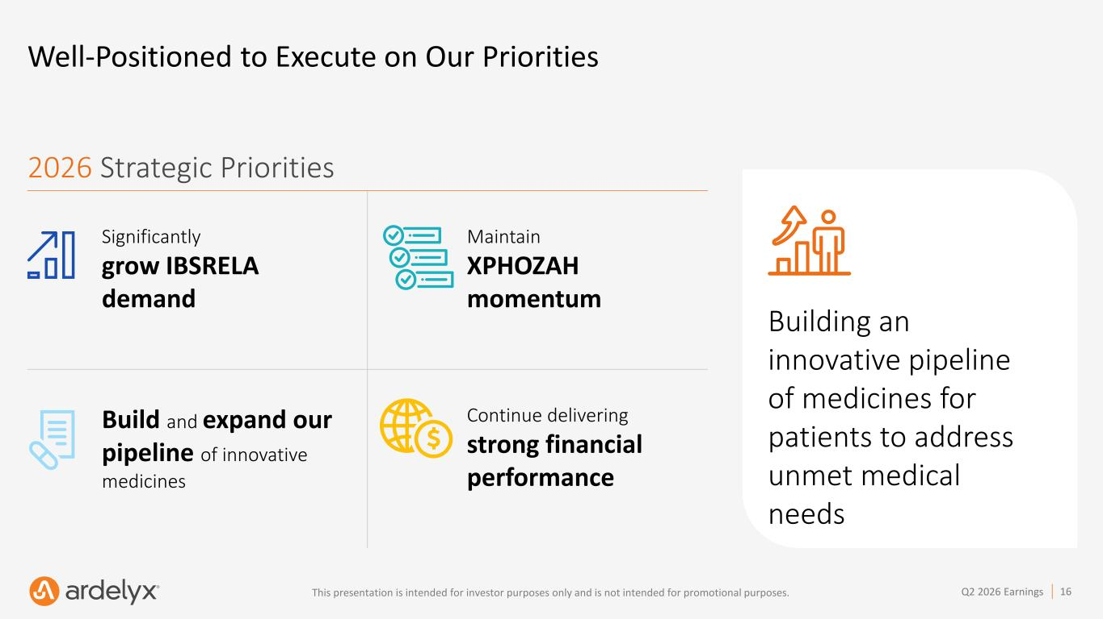
This presentation is intended for investor purposes only and is not intended for promotional purposes. 16Q2 2026 Earnings Significantly grow IBSRELA demand Maintain XPHOZAH momentum Build and expand our pipeline of innovative medicines Continue delivering strong financial performance Well-Positioned to Execute on Our Priorities 2026 Strategic Priorities Building an innovative pipeline of medicines for patients to address unmet medical needs

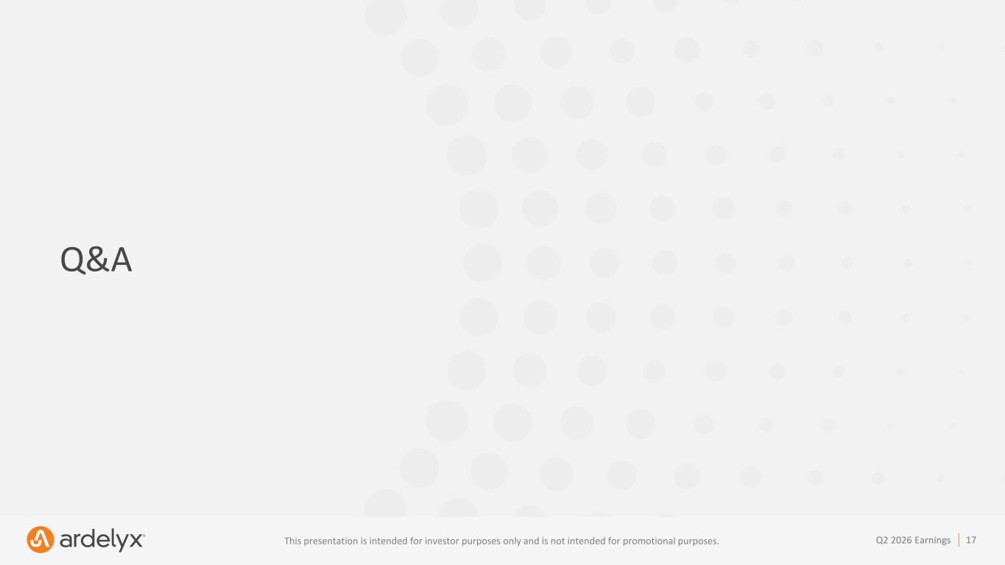
This presentation is intended for investor purposes only and is not intended for promotional purposes. 17Q2 2026 Earnings Q&A


This presentation is intended for investor purposes only and is not intended for promotional purposes. 18Q2 2026 Earnings Thank You

