SEC Form 3
FORM 3 | UNITED STATES SECURITIES AND EXCHANGE COMMISSION
 | Washington, D.C. 20549
 | Washington, D.C. 20549 |  | OMB APPROVAL
 | INITIAL STATEMENT OF BENEFICIAL OWNERSHIP OF SECURITIES
 | INITIAL STATEMENT OF BENEFICIAL OWNERSHIP OF SECURITIES |  | OMB Number: | 3235-0104
 |  |  | Estimated average burden
 | Filed pursuant to Section 16(a) of the Securities Exchange Act of 1934 |  | hours per response: | 0.5
or Section 30(h) of the Investment Company Act of 1940
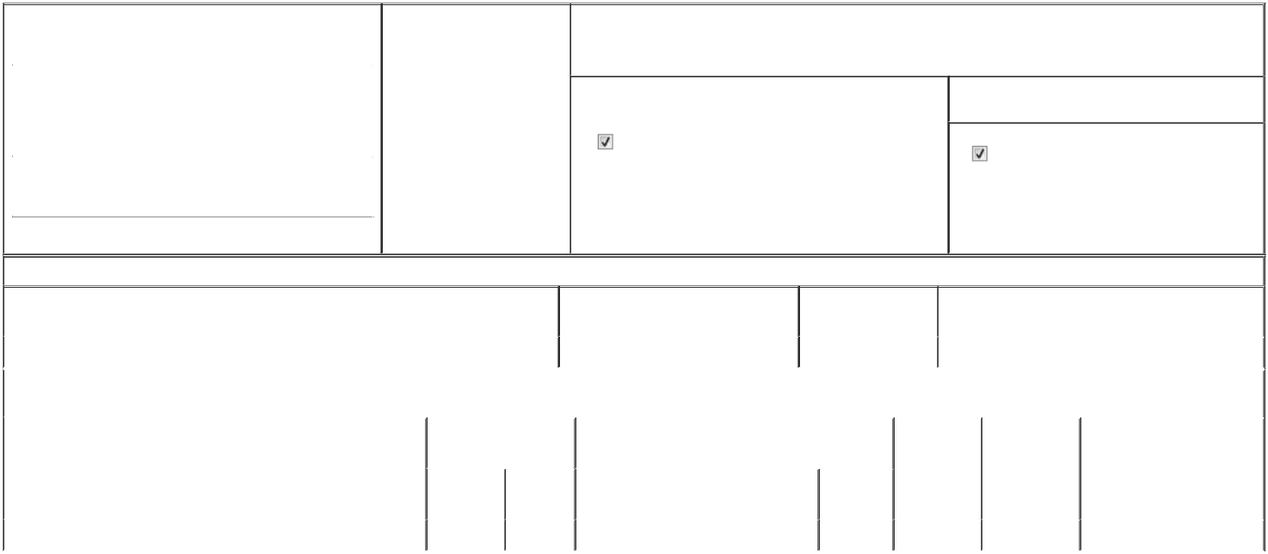

1. Name and Address of Reporting Person* |  |  |  | 2. Date of Event Requiring
 |  | Ettenberg Felecia |  | Statement (Month/Day/Year)
 |  | Ettenberg Felecia |  | 04/20/2026

3. Issuer Name and Ticker or Trading Symbol

ARDELYX, INC. [ ARDX ]

 | (Last) | (First) | (Middle)
 | C/O ARDELYX, INC.
 | 400 FIFTH AVE, SUITE 210
(Street)
 | WALTHAM | MA | 02451

- Relationship of Reporting Person(s) to Issuer (Check all applicable)
Director | 10% Owner
Officer (give title | Other (specify below)
below) | Other (specify below)

Chief Legal Officer

- If Amendment, Date of Original Filed (Month/Day/Year)

- Individual or Joint/Group Filing (Check Applicable Line)

Form filed by One Reporting Person

Form filed by More than One Reporting Person

(City) (State) (Zip)

Table I - Non-Derivative Securities Beneficially Owned

1. Title of Security (Instr. 4) | 2. Amount of Securities Beneficially | 3. Ownership Form: | 4. Nature of Indirect Beneficial Ownership (Instr. 5)
 | Owned (Instr. 4) | Direct (D) or Indirect
 |  | (I) (Instr. 5)

 | Common Stock |  |  |  | 237,000⁽¹⁾ | D
 |  |  | Table II - Derivative Securities Beneficially Owned
 |  | (e.g., puts, calls, warrants, options, convertible securities)
 | 1. Title of Derivative Security (Instr. 4) |  | 2. Date Exercisable and |  | 3. Title and Amount of Securities Underlying |  | 4. | 5. Ownership | 6. Nature of Indirect Beneficial
 |  |  | Expiration Date |  | Derivative Security (Instr. 4) |  | Conversion | Form: Direct | Ownership (Instr. 5)
 |  |  | (Month/Day/Year) |  |  |  | or Exercise | (D) or Indirect
 |  |  |  |  |  |  | Price of | (I) (Instr. 5)
 |  |  |  |  |  | Amount or | Price of | (I) (Instr. 5)
 |  |  |  |  |  | Amount or | Derivative
 |  |  | Date | Expiration | Title | Number of | Security
 |  |  | Exercisable | Date | Title | Shares
 | Stock Option (Right to Buy) | (2) |  | 04/20/2036 | Common Stock | 355,000 | 6.3 | D
 | Explanation of Responses:

- Restricted stock units ("RSUs"). The Reporting Person is entitled to receive one (1) share of Common Stock for each one (1) RSU upon the vesting thereof.

- Twenty Five Percent (25%) of the shares subject to the option vest on April 20, 2027 and the remaining shares subject to the option vest in 36 successive, equal monthly installments thereafter, subject to the Reporting Person's continued employment or service relationship with the Issuer on each such vesting date.

Remarks:

Exhibit 24.1 - Power of Attorney

 | /s/ Shannon Moesaa, Attorney-in-Fact |  |  | 04/22/2026
 | for Felecia Ettenberg
 | ** Signature of Reporting Person |  |  | Date
Reminder: Report on a separate line for each class of securities beneficially owned directly or indirectly.
* If the form is filed by more than one reporting person, see Instruction 5 (b)(v).
** Intentional misstatements or omissions of facts constitute Federal Criminal Violations See 18 U.S.C. 1001 and 15 U.S.C. 78ff(a).
Note: File three copies of this Form, one of which must be manually signed. If space is insufficient, see Instruction 6 for procedure.
Persons who respond to the collection of information contained in this form are not required to respond unless the form displays a currently valid OMB Number.



