SEC Form 4

FORM 4

Check this box if no longer subject to Section 16. Form 4 or Form 5 obligations may continue. See Instruction 1(b).

Check this box to indicate that a transaction was made pursuant to a contract, instruction or written plan for the purchase or sale of equity securities of the issuer that is intended to satisfy the affirmative defense conditions of Rule 10b5-1(c). See Instruction 10.

UNITED STATES SECURITIES AND EXCHANGE COMMISSION
Washington, D.C. 20549
Washington, D.C. 20549 |  | OMB APPROVAL
STATEMENT OF CHANGES IN BENEFICIAL OWNERSHIP
STATEMENT OF CHANGES IN BENEFICIAL OWNERSHIP |  | OMB Number: | 3235-0287
 |  | Estimated average burden
Filed pursuant to Section 16(a) of the Securities Exchange Act of 1934 |  | hours per response: | 0.5
or Section 30(h) of the Investment Company Act of 1940
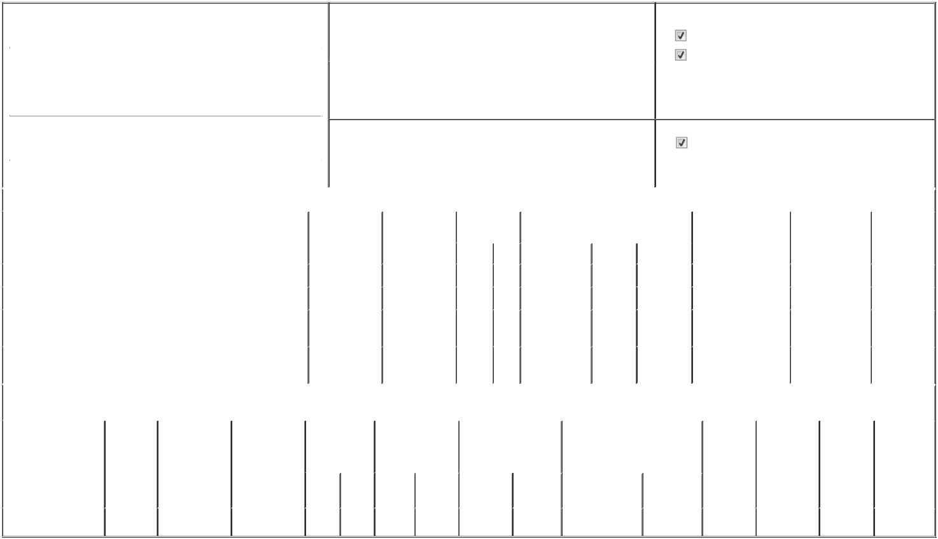

1. Name and Address of Reporting Person* |  |  |  |  | 2. |  |  | Issuer Name and Ticker or Trading Symbol
 | RAAB MICHAEL |  |  |  |  |  | ARDELYX, INC. [ ARDX ]
 | (Last) | (First) |  | (Middle)
 | (Last) |  |  | (Middle) | 3. |  |  | Date of Earliest Transaction (Month/Day/Year)
 | C/O ARDELYX, INC.
 | C/O ARDELYX, INC. |  |  |  | 06/15/2026

400 FIFTH AVENUE, SUITE 210

- Relationship of Reporting Person(s) to Issuer (Check all applicable)

Director | 10% Owner
Officer (give title | Other (specify below)
below) | Other (specify below)

President & CEO

 | (Street) |  |  |  |  |  | 4. If Amendment, Date of Original Filed (Month/Day/Year) |  |  |  |  |  |  |  | 6. Individual or Joint/Group Filing (Check Applicable Line)
 |  | WALTHAM | MA | 02451 |  |  |  |  |  |  |  |  |  |  |  |  | Form filed by One Reporting Person
 |  |  |  |  |  |  |  |  |  |  |  |  |  |  |  |  | Form filed by More than One Reporting Person
 |  | (City) | (State) | (Zip)
 |  |  |  |  | Table I - Non-Derivative Securities Acquired, Disposed of, or Beneficially Owned
 | 1. Title of Security (Instr. 3) |  |  |  |  | 2. Transaction |  | 2A. Deemed |  | 3. Transaction |  | 4. Securities Acquired (A) or Disposed Of |  |  |  | 5. Amount of Securities |  |  | 6. Ownership |  | 7. Nature of
 |  |  |  |  |  | Date |  | Execution Date, |  | Code (Instr. 8) |  | (D) (Instr. 3, 4 and 5) |  |  |  | Beneficially Owned |  |  | Form: Direct (D) or |  | Indirect
 |  |  |  |  |  | (Month/Day/Year) |  | if any |  |  |  |  |  |  |  | Following Reported |  |  | Indirect (I) (Instr. 4) |  | Beneficial
 |  |  |  |  |  |  |  | (Month/Day/Year) |  | Code | V | Amount |  | (A) or (D) | Price | Transaction(s) (Instr. 3 |  |  |  |  | Ownership
 |  |  |  |  |  |  |  |  |  | Code | V | Amount |  | (A) or (D) | Price | and 4) |  |  |  |  | (Instr. 4)
 | Common Stock |  |  |  |  | 06/15/2026 |  |  |  | _{M}(1) |  | 20,833 |  | A | $0.99 | 1,740,866 |  |  |  | D
 | Common Stock |  |  |  |  | 06/15/2026 |  |  |  | _{S}(1) |  | 41,666 |  | D | $5.6724⁽²⁾ | 1,699,200 |  |  |  | D
 | Common Stock |  |  |  |  |  |  |  |  |  |  |  |  |  |  | 24,364 |  |  |  | I | Family
 |  |  |  |  |  |  |  |  |  |  |  |  |  |  |  |  |  |  |  | I | Trust⁽³⁾
 | Common Stock |  |  |  |  |  |  |  |  |  |  |  |  |  |  | 1,000 |  |  |  | I | Family
 |  |  |  |  |  |  |  |  |  |  |  |  |  |  |  |  |  |  |  | I | Trust⁽⁴⁾
 |  |  |  |  | Table II - Derivative Securities Acquired, Disposed of, or Beneficially Owned
 |  |  |  |  |  | (e.g., puts, calls, warrants, options, convertible securities)
 | 1. Title of Derivative |  | 2. | 3. Transaction | 3A. Deemed | 4. Transaction |  | 5. Number of |  | 6. Date Exercisable and |  |  | 7. Title and Amount of Securities |  |  |  | 8. Price of | 9. Number of |  | 10. | 11. Nature of
 | Security (Instr. 3) |  | Conversion | Date | Execution Date, | Code (Instr. 8) |  | Derivative |  | Expiration Date |  |  | Underlying Derivative Security |  |  |  | Derivative | derivative |  | Ownership | Indirect
 |  |  | or Exercise | (Month/Day/Year) | if any |  |  | Securities Acquired |  | (Month/Day/Year) |  |  | (Instr. 3 and 4) |  |  |  | Security | Securities |  | Form: | Beneficial
 |  |  | Price of |  | (Month/Day/Year) |  |  | (A) or Disposed of |  |  |  |  |  |  |  |  | (Instr. 5) | Beneficially |  | Direct (D) or | Ownership
 |  |  | Derivative |  |  |  |  | (D) (Instr. 3, 4 and 5) |  |  |  |  |  |  |  |  |  | Owned |  | Indirect (I) | (Instr. 4)
 |  |  | Security |  |  |  |  |  |  |  |  |  |  |  |  |  |  | Following |  | (Instr. 4)
 |  |  |  |  |  |  |  |  |  |  |  |  |  |  | Amount or |  |  | Reported
 |  |  |  |  |  |  |  |  |  | Date |  | Expiration |  |  | Number of |  |  | Transaction(s)
 |  |  |  |  |  | Code V |  | (A) | (D) | Exercisable |  | Date | Title |  | Shares |  |  | (Instr. 4)
 | Stock Option (Right to |  | $0.99 | 06/15/2026 |  | _{M}(1) |  |  | 20,833 | (5) |  | 01/06/2032 |  | Common Stock | 20,833 | $0 |  | 311,668 |  | D
 | Buy) |  | $0.99 | 06/15/2026 |  |  |  |  | 20,833 | (5) |  | 01/06/2032

Explanation of Responses:

- Transaction made pursuant to a 10b5-1 trading plan adopted by the Reporting Person on November 7, 2025.

- Transaction was executed in multiple trades in prices ranging from $5.625 to $5.77, inclusive. The price reported in Column 4 above reflects the weighted average sale price. The Reporting Person hereby undertakes to provide to the Securities and Exchange Commission staff, the Issuer, or a security holder of the Issuer, upon request, full information regarding the number of shares sold at each respective price within the range set forth in this footnote.

- The shares are directly held by Michael G. Raab, Trustee of the Michael G. Raab Living Trust dated July 25, 2012.

- The shares are owned directly by trusts for the benefit of the Reporting Person's children.

- The option becomes exercisable as it vests and the shares subject to the option vest in 48 successive, equal monthly installments on each monthly anniversary of January 6, 2022, subject to the Reporting Person's continued employment or service relationship with the Issuer on each such vesting date.

Remarks:

Exhibit 24.1 - Power of Attorney

 | /s/ Felecia Ettenberg, Attorney-in-Fact |  |  | 06/17/2026
 | for Michael Raab
 | ** Signature of Reporting Person |  |  | Date
Reminder: Report on a separate line for each class of securities beneficially owned directly or indirectly.
* If the form is filed by more than one reporting person, see Instruction 4 (b)(v).
** Intentional misstatements or omissions of facts constitute Federal Criminal Violations See 18 U.S.C. 1001 and 15 U.S.C. 78ff(a).
Note: File three copies of this Form, one of which must be manually signed. If space is insufficient, see Instruction 6 for procedure.
Persons who respond to the collection of information contained in this form are not required to respond unless the form displays a currently valid OMB Number.



